Methods I Midterm Revision exercises

- A researcher examines the effects of two variables on memory. One variable is beverage (caffeine or no caffeine) and the other variable is the subject to be remembered (numbers, word lists, aspects of a story). Subjects have to recall information and the number of items recalled is measured.
  - Identify the independent and dependent variables.
Independent: beverage and subject to be remembered
Dependent: number of items recalled
  - How many levels do the variables of “beverage” and “subject to be remembered” have?
beverage: two levels: caffeine and no caffeine
subject to be remembered: three levels: numbers, word lists, and aspects of a story
- Let’s say you wanted to study the impact of declaring a major on school-related anxiety. You recruit 50 first-year university students who have not declared a major and 50 first-year university students who have declared a major. You have all 100 students complete an anxiety measure.
  - What is the independent variable in this study? declaring a major
  - What are the levels of the independent variable? declared, and have not declared
  - What is the dependent variable? anxiety measure
- A father rates his daughter as a 2 on a 7-point scale of crankiness. In this example, what is the variable, what is the score, and what is the possible range of values?
crankiness is the variable, 2 is the score, and 1 – 7 is the possible range of values
- A participant in a cognitive psychology study is given 50 words to remember and later asked to recall as many of the words as she can. She recalls 17 words. What is the variable, possible values, and score?
number of words recalled is the variable, possible values are 0 – 50, the score is 17
- Give the level of measurement of each of the following variables:
  - a person’s nationality (Mexican, Chinese, Ethiopian, Australian, etc.), nominal/categorical
  - a person’s score on a standard IQ test, interval/scale
  - a person’s place on a waiting list (first in line, second in line, etc.). ordinal
- Make a frequency table for the following scores: 5, 7, 4, 5, 6, 5, 4.
Value Frequency
4 2
5 3
6 1
7 1
- Make a histogram based on the following frequency table:
Value | Frequency
1 | 3
2 | 4
3 | 8
4 | 5
5 | 2

- Describe the difference between a unimodal and multimodal distribution.
Unimodal has one mode (most frequent value), multimodal has more than one mode
- What kind of skew is created by (a) a floor effect and (b) a ceiling effect?
floor effect: negative (left) skew, ceiling effect: positive (right) skew
- For each of the types of data described below, would you present individual data values or grouped data when creating a frequency distribution? Explain your answer clearly.
  - Minutes used on a cell phone by 240 teenagers grouped
  - Time to complete the Boston Marathon for the nearly 22,000 runners who participate grouped
  - Number of siblings for 64 college students individual (grouped if you believe that students may have a large number of siblings)
- Deciding what kind of graph to use depends largely on how variables are measured. Imagine a researcher is interested in how “quality of sleep” is related to typing performance (measured by the number of errors made). For each of the measures of sleep below, decide what kind of graph to use.
  - Total minutes slept scatter plot
  - Sleep assessed as sufficient or insufficient . bar graph
  - Using a scale from 1 (low quality sleep) to 7 (excellent sleep) bar graph, possibly scatter plot
- Name and define three measures of central tendency.
mean: the arithmetic average
median: the middle score
mode: the most frequent score
- Describe and explain the location of the mean, mode, and median for a normal curve.
all three are in the centre of the distribution
- Describe and explain the location of the mean, mode, and median of a distribution of scores that is strongly skewed to the left.
all three will shift to the right and the mode will be the rightmost measure
- Consider these three variables: finishing times in a marathon, number of correct answers by the control groups versus the experimental group of young children, and scores on a scale of extroversion.
  - Which of these variables is most likely to have a normal distribution? Explain your answer. scores on a scale of extroversion
  - Which of these variables is most likely to have a negatively skewed distribution? Explain your answer, stating the possible contribution of a floor effect. finishing times in a marathon (most people take a long time)
  - Which of these variables is most likely to have a positively skewed distribution? Explain your answer, stating the possible contribution of a ceiling effect. the scores of adult controls (they are likely to perform at ceiling)
- What is an outlier? Does an outlier have the greatest effect on the mean, median, or mode?
an extreme value; it has the greatest effect on the mean
- Define the following measures of variability and describe what they tell you about a group of scores:
  - Variance the average squared difference from the mean
  - Standard deviation the square root of the variance (measured in the unit of the scores)
  - Range the difference between the largest and the smallest value
  - Interquartile range the difference between the third quartile (75th percentile) and the first quartile (25th percentile) of the scores
- What is the advantage of the interquartile range over the range? it balances out outliers
- Why is the standard deviation more useful than the variance? because it uses the unit of the score
- Guinness World Records relies on what kind of data for its amazing claims? How does this relate to the calculation of ranges? outliers, which stretch the range
- A study involves measuring the number of days absent from work for 216 employees of a large company during the preceding year. As part of the results, the researcher reports, “The number of days absent during the preceding year (M = 9.21; SD = 7.342) was . . . .” Explain what is written in parentheses to a person who has never had a course in statistics.
People were on average a little over 9 days absent from work and there was a lot of variation between employees (on average, people were absent 7.3 days more or less than 9 days).
- You figure the variance of a distribution of scores to be –4.26. Explain why your answer cannot be correct. the variance is the squared difference from the mean so it cannot be a negative value
- Figure the mean, median, variance and standard deviation for the following scores:
2, 4, 3 and 7. M = 4, s² = ((2-4)²+ (4-4)²+ (3-4)²+ (7-4)²)/(4-1) = 4.67, SD = 2.16
- Calculate the interquartile range and draw a box plot for the following set of data:
2, 5, 1, 3, 3, 4, 3, 6, 7, 1, 4, 3, 7, 2, 2, 2, 8, 3, 3, 12, 1 interquartile range: 3
- A two-tailed test is used when we do not predict the direction that scores will change; a one-tailed test is used when we do predict the direction that scores will change.
- The research (alternative, experimental) hypothesis says that the sample data represent a population where the predicted relationship exists. The null hypothesis says that the sample data represent a population where the predicted relationship does not exist.
- Describe the Research (experimental, alternative) and Null hypotheses and the independent and dependent variables when we study:
  - whether the amount of pizza consumed by students during exam period increases relative to the rest of the semester,
Research: more pizza is consumed during the exam period; Null: nor more pizza is consumed during exam period; one-tailed
  - whether breathing exercises alter blood pressure,
Research: breathing exercises alter blood pressure; Null: breathing exercises do not alter blood pressure; two-tailed
  - whether sensitivity to pain is affected by increased hormone levels, and
Research: sensitivity to pain is affected by increased hormone levels; Null: sensitivity to pain is not affected by increased hormone levels; two-tailed
  - whether frequency of daydreaming decreases as a function of more light in the room.
Research: people daydream less if there is no light in the room; Null: people do not daydream less if there is more light in the room; one-tailed
- For each study in the previous question, indicate whether a one- or a two-tailed test should be used.
- At the end of a study, what does it mean to reject the null hypothesis? Being satisfied that the null hypothesis is probably wrong
- Explain how Type I and Type II errors both relate to the null hypothesis.
Type I: false alarm, when the null hypothesis is rejected even though it should not have been
Type II: miss, when the null hypothesis is not rejected even though it should have been
- If out of every 280 people in prison, 7 people are innocent, what is the rate of Type I errors? 2.5%
- If the court system fails to convict 11 out of every 35 guilty people, what is the rate of Type II errors? 31.4%
- How is a Z score related to a raw score? the Z score is the number of standard deviations the score differs from the mean (Z = (X-M)/SD)
- Write the formula for changing a raw score to a Z score, and define each of the symbols. X = Z*SD + M (where X is the score, M is the mean of scores and SD is the standard deviation)
- Suppose a person has a Z score for overall health of +2 and a Z score for overall sense of humor of +1. What does it mean to say that this person is healthier than she is funny?
The Z score of +2 means that the person’s health score is two standard deviations above the mean, while the Z score of +1 means that the person’s humour score is only one standard deviation above the mean; that is, their health has a higher rank in the health scale than their humour in the humour scale.
- Data have been collected nationally from 10,000 fifth graders on a test of reading comprehension and a test of arithmetic skills.
Reading Arithmetic
M = 104 M = 64
SD = 10 SD = 8
  - The scores of 3 children in the fifth grade of Grundy Center Elementary School are listed below. Find their z score on each test. (show all work)
Pupil Reading Arithmetic z_{R} z_{A}
1 116 72 1.2 1
2 81 58 -2.3 -0.75
3 98 76 -0.6 1.5

  - Which child was most consistent in performances, in terms of relative standing, on the two tests? Which was least consistent?
Child 1 was most consistent: about one standard deviation above the mean in both tests
Child 3 is least consistent: below average in reading but well above average in arithmetic
  - The z scores for three children are listed below. What are their raw scores? (show all work)

Reading Arithmetic Reading Arithmetic
Pupil z Score z Score Raw Score Raw Score

1 +1.40 +1.75 118 78

2 -2.60 -1.25 78 54

3 -.30 +2.50 101 84
  - If one of the children had a 109 on the reading comprehension test, what raw score would he have had to make on the arithmetic skills test to earn the same z score on both tests? 68 (half a standard deviation more than the mean)
- Complete the graph with the expected probabilities of the distribution (What percentage of scores will fall under the different parts of the curve):
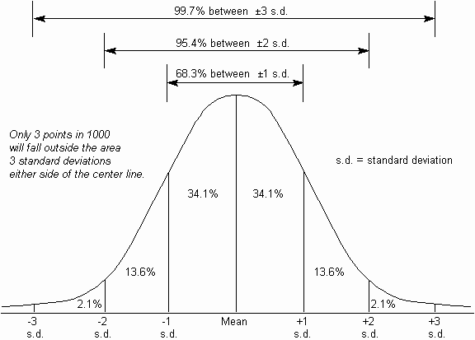
- About what percentage of scores on a normal curve are
  - above the mean, 50
  - between the mean and 1 SD above the mean, 34
  - between 1 and 2 SDs above the mean, 14
  - below the mean, 50
  - between the mean and 1 SD below the mean, and 34
  - between 1 and 2 SDs below the mean? 14
- About what Z score would a person have who has a lower score than
  - 50% of the scores, 0
  - 16%, of the scores -1
  - 84% of the scores, 1
  - 2.5% of the scores? -2
- Suppose people’s scores on a particular personality test are normally distributed with a mean of 50 and a standard deviation of 10. If you were to pick a person completely at random, what is the probability you would pick someone with a score on this test higher than 60?
16% (a score of 60 is 1 SD over the mean, and about 16% of scores are higher than that)
- Credit card companies will often call cardholders if the pattern of use indicates that the card might have been stolen. Say you charge an average of 20,000 forints a month on your credit card, with a standard deviation of 5,000 forints. The credit card company will call you anytime your purchases for the month exceed the 98th percentile. What is the dollar amount beyond which you’ll get a call from your credit card company?
if the purchases are more than about 2 SD more than the average spending: 20,000 + 2*5,000 = 30,000. You’ll get a call beyond about 30,000.
- What is the central limit theorem? What does it say about outliers and standard deviations? How do we calculate the standard error?
it states that if you take several samples from a population and plot their means, the distribution of these sample means will approximate a normal distribution even if the scores of the individual samples are not normally distributed. Outliers will be smoothed and the standard deviation of the sample means will be much smaller than the standard deviation of individual scores. The standard deviation of sample means is called the standard error.
- What are point estimates and interval estimates? Which is more useful for testing whether the null hypothesis is correct? Why?
A point estimate is a single value to which we compare another value to see whether the null hypothesis can be rejected: e.g. the comparison population mean to which we compare the mean of our experimental sample. An interval estimate is an interval rather than a single value to which we compare the sample mean to test whether our sample is likely to come from the comparison population. An interval estimate is more useful because comparing two means does not reveal much (we can’t reject the null hypothesis just because the two means are not exactly the same). But we can determine the interval in which the sample mean should fall if the sample is unlikely to be different from the comparison population.
- What is a confidence interval? What is a 95% confidence interval? What is a 99% confidence interval?
A confidence interval is a range of plausible values: the interval of values in which the sample mean should fall if the sample is likely to come from the comparison population. A 95% confidence interval means that there is a 95% chance that the sample mean will fall in that interval if the sample comes from the comparison population. A 99% confidence interval means that there is a 99% chance.
- What is effect size? The size of the effect of the treatment, i.e. it tells us how large the difference is between the comparison population and the experimental sample.
  - How is effect size affected by the size of the difference between the means we are comparing? The greater the difference between the means, the greater the effect size.
  - How is effect size affected by the standard deviations of population distributions were are comparing? The greater the standard deviation of the comparison population, the smaller the effect size.
- What is Cohens’ d? How do you calculate it? It is a standardised measure of effect size. d = (sample Mean – comparison population mean)/comparison population or pooled standard deviation.
- What is a meta-analysis? Why is effect size useful for a meta-analysis?
A meta-analysis is a comparison of the results of different studies concerned with the same topic. Effect sizes and their confidence intervals are useful because they are standardised measures and do not depend on the different measurement scales used by the various researchers doing the studies that are to be compared in the meta-analysis.
- What is statistical power? Explain what it means if the statistical power of a research is 40%. If it is 80%? Statistical power is a measure of the study’s ability to reject the null hypothesis if it is false, in other words the likelihood of not missing a statistically significant result. 40% power means that there is a 40% likelihood that significant results won’t be missed, i.e., if the study was repeated 100 times, statistically significant results won’t be missed in 40 cases but they will be missed in the remaining 60 cases. 80% power means that there is an 80% probability that a significant results won’t be missed.
  - What factors affect statistical power? sample size, standard deviation, size of difference between the means, the level of alpha, whether the hypothesis is one-tailed or two-tailed
  - What information does a statistical power calculator need to calculate statistical power? estimates of all of the above
  - You can use the statistical power calculator to estimate an important practical parameter in your research. What is it? sample size: we can use the calculator to estimate how many participants we need to achieve if we want 70% or 80% or 90% statistical power.
- Chefs claim that they are more sensitive to smell than other people.
These are the scores on a test of sensitivity to smell taken by chefs attending a national conference (a higher score means greater sensitivity):
96, 83, 59, 64, 73, 74, 80, 68, 87, 67, 64, 92, 76, 71, 68, 50, 85, 75, 81, 70, 76, 91, 69, 83, 75
These are the scores on a test of sensitivity to smell taken by ordinary mortals:
23, 39, 72, 25, 46, 51, 22, 19, 38, 37, 42, 49, 33, 29, 21, 27, 35, 36, 43, 41, 26, 37, 51, 5, 37, 43, 38
  - What are the research (experimental, alternative) and null hypotheses? Research: Chefs score higher on a smell sensitivity test than the general population. Null: chefs do not score any higher than the general population.
  - What are the dependent and independent variables? How would you enter the data into SPSS? Dependent: score on smell sensitivity test, Independent: chef versus non-chef. SPSS: each person in one row, 1 column specifying whether the individual is a member of the chef group or a member of the general population (non-chef group), 1 column with the score, and possibly 1 ID column.
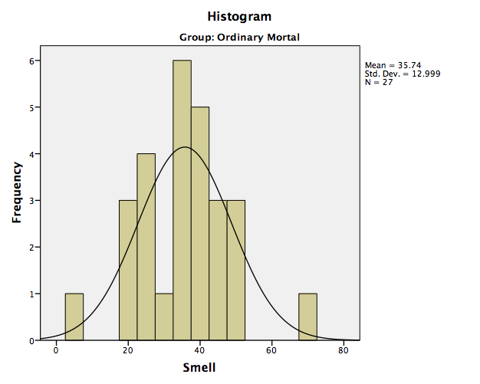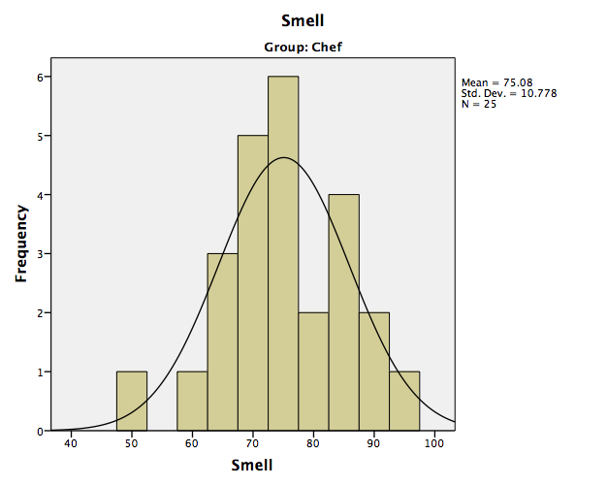

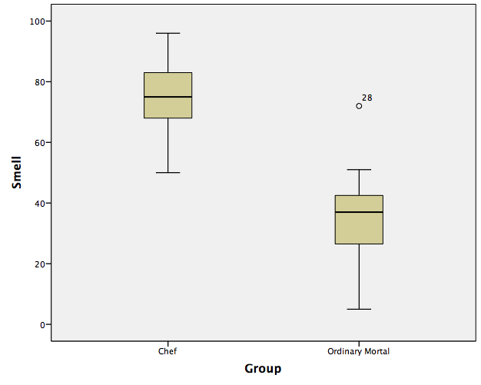

  - Check the distribution (histograms, box plots, outliers, normality test) We are mostly interested in the comparison population (the control group). There is one outlier (whose smell sensitivity is much higher than everybody else’s). But we probably do not have to do anything about this person, since the normality test tells us that the distribution is not significantly different from normal, even though the histogram looks a little messy.
The chef scores are also normally distributed and there are no outliers.
  - Calculate appropriate measures of central tendency and spread.
Control group: M = 35.74, SD = 13.0; Chef group: M = 75.08, SD = 10.78
There is a difference between the means in the right direction but it could be due to chance.
  - Calculate confidence intervals, draw graphs.
Control group: M = 35.74[30.6, 40.9], Chef group: M = 75.08[70.63, 79.53]
There is no overlap.
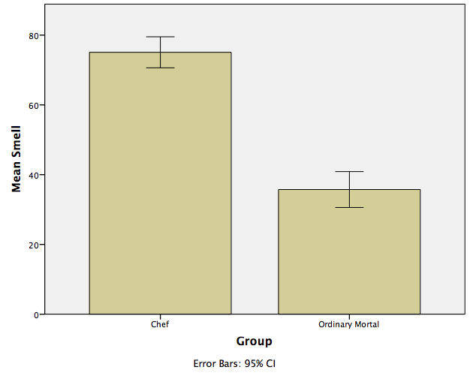

  - Calculate Cohen’s d. d = 3.28
  - What conclusion can you draw? The probability of the chefs coming from the general population is very low, i.e., being a chef is very likely to improve smell sensitivity. The effect is very large.

